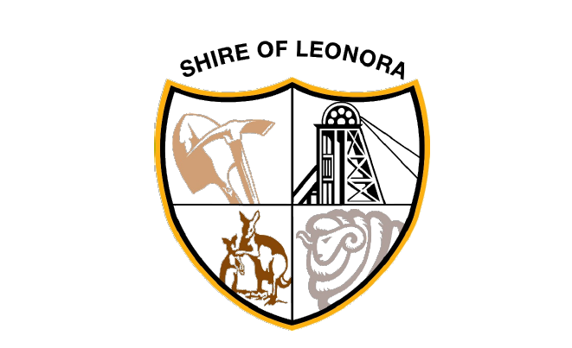

PUBLIC NOTICE

ADOPTION OF 2024/25 SCHEDULE OF FEES AND CHARGES

At the Shire of Leonora Ordinary Council Meeting of 18 June 2024, pursuant to s6.16-s6.19 of the Local Government Act 1995, Council adopted the 2024/2025 Schedule of Fees and Charges.
The Shire of Leonora gives notice of its intention to implement the 2024/2025 Schedule of Fees and Charges from 1 July 2024.
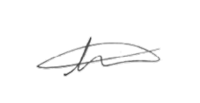
Ty Matson
CHIEF EXECUTIVE OFFICER

